FUNDAMENTALS OF DATA SCIENCE

LAB PROGRAMS

DSA 0412-Fundamentals Of Data Science for Data Analytics

M S GOWRISH SHANKAR REDDY
192424270

23/01/2026

23.You are a researcher working in a medical lab, investigating the effectiveness of a new treatment
for a specific disease. You have collected data from a clinical trial with two groups: a control group
receiving a placebo, and a treatment group receiving the new drug.Your goal is to analyze the data
using hypothesis testing and calculate the p-value to determine if the new treatment has a
statistically significant effect compared to the placebo. You will use the matplotlib library to
visualize the data and the p-value.
Code:
import pandas as pd
import matplotlib.pyplot as plt
from scipy import stats

data = pd.read_csv("clinical_trial_data.csv")

placebo = data[data["Group"] == "Placebo"]["Reduction"]
treatment = data[data["Group"] == "Treatment"]["Reduction"]

t_stat, p_value = stats.ttest_ind(treatment, placebo)

print("T-statistic:", round(t_stat, 3))
print("P-value:", round(p_value, 6))

alpha = 0.05

if p_value < alpha:
print("Result: Statistically significant difference (Reject H0)")
else:
print("Result: No statistically significant difference (Fail to reject H0)")
plt.figure()
plt.boxplot([placebo, treatment], labels=["Placebo", "Treatment"])
plt.title("Clinical Trial Results\nP-value = " + str(round(p_value, 6)))
plt.ylabel("Reduction in Disease Severity")
plt.show()
Output:
T-statistic: 14.893
P-value: 0.0
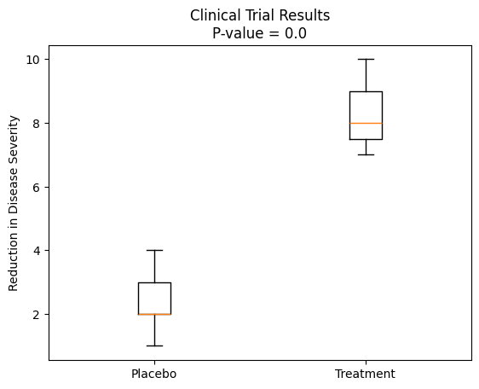
Result: Statistically significant dif ference (Reject H0)

24.Question: K-Nearest Neighbors (KNN) Classifier
You are working on a classification problem to predict whether a patient has a certain medical
condition or not based on their symptoms. You have collected a dataset of patients with labeled
data (0 for no condition, 1 for the condition) and various symptom features.
Write a Python program that allows the user to input the features of a new patient and the value of k
(number of neighbors). The program should use the KNN classifier from the scikit-learn library to
predict whether the patient has the medical condition or not based on the input features.
Code:
import pandas as pd
from sklearn.neighbors import KNeighborsClassifier

data = pd.read_csv("patient_data.csv")

X = data[["Fever", "Headache", "Fatigue", "Cough"]]
y = data["Condition"]

k = int(input("Enter value of k (number of neighbors): "))

model = KNeighborsClassifier(n_neighbors=k)
model.fit(X, y)

fever = int(input("Fever (1 = Yes, 0 = No): "))
headache = int(input("Headache (1 = Yes, 0 = No): "))
fatigue = int(input("Fatigue (1 = Yes, 0 = No): "))
cough = int(input("Cough (1 = Yes, 0 = No): "))

new_patient = [[fever, headache, fatigue, cough]]
prediction = model.predict(new_patient)

if prediction[0] == 1:
print("Prediction: Patient HAS the medical condition")
else:
print("Prediction: Patient does NOT have the medical condition")
Output:
Enter value of k (number of neighbors): 4
Fever (1 = Yes, 0 = No): 1
Headache (1 = Yes, 0 = No): 1
Fatigue (1 = Yes, 0 = No): 0
Cough (1 = Yes, 0 = No): 1
Prediction: Patient HAS the medical condition

29.Question: Evaluation Metrics for Model Performance
You have trained a machine learning model on a dataset, and now you want to evaluate its
performance using various metrics.
Write a Python program that loads a dataset and trained model from scikit-learn. The program
should ask the user to input the names of the features and the target variable they want to use for
evaluation. The program should then calculate and display common evaluation metrics such as
accuracy, precision, recall, and F1-score for the model's predictions on the test data.
Code:
import pandas as pd
from sklearn.model_selection import train_test_split
from sklearn.linear_model import LogisticRegression
from sklearn.metrics import accuracy_score, precision_score, recall_score, f1_score

# Load dataset
df = pd.read_csv("data.csv")

# User inputs
feature_names = input("Enter feature names (comma-separated): ").split(",")
feature_names = [f.strip() for f in feature_names]
target_name = input("Enter target variable name: ").strip()

# Prepare data
X = df[feature_names]
y = df[target_name]

# Train-test split
X_train, X_test, y_train, y_test = train_test_split(
X, y, test_size=0.3, random_state=42
)

# Train model (example: Logistic Regression)
model = LogisticRegression()
model.fit(X_train, y_train)

# Predictions
y_pred = model.predict(X_test)

# Evaluation metrics
accuracy = accuracy_score(y_test, y_pred)
precision = precision_score(y_test, y_pred, zero_division=0)
recall = recall_score(y_test, y_pred, zero_division=0)
f1 = f1_score(y_test, y_pred, zero_division=0)

# Display results
print("\nModel Evaluation Metrics:")
print("Accuracy :", round(accuracy, 4))
print("Precision:", round(precision, 4))
print("Recall :", round(recall, 4))
print("F1-score :", round(f1, 4))
Output:
Enter feature names (comma-separated): Feature1, Feature2, Feature3
Enter target variable name: Target

Model Evaluation Metrics:
Accuracy : 0.3333
Precision: 0.3333
Recall : 1.0
F1-score : 0.5

32. Scenario: You work as a data scientist for a real estate company. The company has collected
data on various houses, including features such as the size of the house, number of bedrooms,
location, and other relevant attributes. The marketing team wants to build a predictive model to
estimate the price of houses based on their features. They believe that linear regression modeling
can be an effective approach for this task.
Question:Your task is write a Python program to perform bivariate analysis and build a linear
regression model to predict house prices based on a selected feature (e.g., house size) from the
dataset. Additionally, you need to evaluate the model's performance to ensure its accuracy and
reliability.
Code:
import pandas as pd
import matplotlib.pyplot as plt
from sklearn.linear_model import LinearRegression
from sklearn.model_selection import train_test_split
from sklearn.metrics import mean_squared_error, r2_score

data = pd.read_csv("house_price_bivariate.csv")

X = data[["Size_sqft"]]
y = data["Price"]

plt.figure()
plt.scatter(X, y)
plt.xlabel("House Size (sqft)")
plt.ylabel("Price")
plt.title("Bivariate Analysis: House Size vs Price")
plt.show()

X_train, X_test, y_train, y_test = train_test_split(
X, y, test_size=0.2, random_state=42
)

model = LinearRegression()
model.fit(X_train, y_train)

y_pred = model.predict(X_test)

plt.figure()
plt.scatter(X_test, y_test)
plt.plot(X_test, y_pred)
plt.xlabel("House Size (sqft)")
plt.ylabel("Price")
plt.title("Linear Regression: Actual vs Predicted Prices")
plt.show()

print("Mean Squared Error:", round(mean_squared_error(y_test, y_pred), 2))
print("R-squared Score:", round(r2_score(y_test, y_pred), 2))
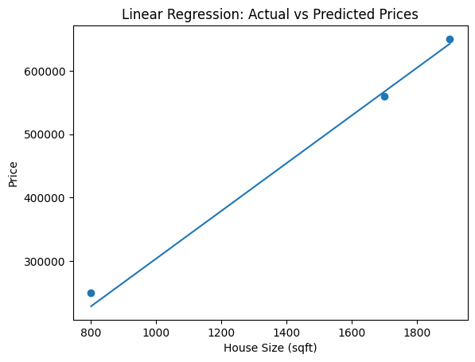
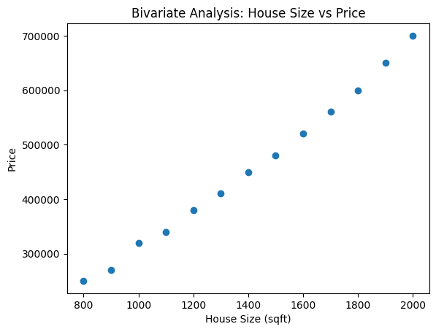
output:

34. Scenario: Suppose you are working as a data scientist for a medical research organization.
Your team has collected data on patients with a certain medical condition and their treatment
outcomes. The dataset includes various features such as age, gender, blood pressure, cholesterol
levels, and whether the patient responded positively ("Good") or negatively ("Bad") to the
treatment. The organization wants to use this model to identify potential candidates who are likely
to respond positively to the treatment and improve their medical approach.
Question: Your task is to build a classification model using the KNN algorithm to predict the
treatment outcome ("Good" or "Bad") for new patients based on their features. Evaluate the model's
performance using accuracy, precision, recall, and F1-score.Make predictions on the test set and
display the results.
Code:
import pandas as pd
from sklearn.model_selection import train_test_split
from sklearn.neighbors import KNeighborsClassifier
from sklearn.preprocessing import LabelEncoder
from sklearn.metrics import accuracy_score, precision_score, recall_score, f1_score

data = pd.read_csv("medical_treatment_data.csv")

X = data[["Age", "Gender", "Blood_Pressure", "Cholesterol"]]
y = data["Outcome"]

label_encoder = LabelEncoder()
y = label_encoder.fit_transform(y)

X_train, X_test, y_train, y_test = train_test_split(
X, y, test_size=0.3, random_state=42
)

k = 3
model = KNeighborsClassifier(n_neighbors=k)
model.fit(X_train, y_train)

y_pred = model.predict(X_test)

print("Predicted Outcomes (encoded):", y_pred)
print("Actual Outcomes (encoded): ", y_test.values)

print("\nModel Performance Metrics:")
print("Accuracy :", round(accuracy_score(y_test, y_pred), 4))
print("Precision:", round(precision_score(y_test, y_pred), 4))
print("Recall :", round(recall_score(y_test, y_pred), 4))
print("F1-score :", round(f1_score(y_test, y_pred), 4))
Output:
Predicted Outcomes (encoded): [1 0 1 1 0]
Actual Outcomes (encoded): [1 1 1 1 0]

Model Performance Metrics:
Accuracy : 0.8
Precision: 1.0
Recall : 0.75
F1-score : 0.8571

